Java 8
- Write the following a functional interface and implement it using lambda:
(1) First number is greater than second number or not Parameter (int ,int ) Return boolean
(2) Increment the number by 1 and return incremented value Parameter (int) Return int
(3) Concatination of 2 string Parameter (String , String ) Return (String)
(4) Convert a string to uppercase and return . Parameter (String) Return (String)
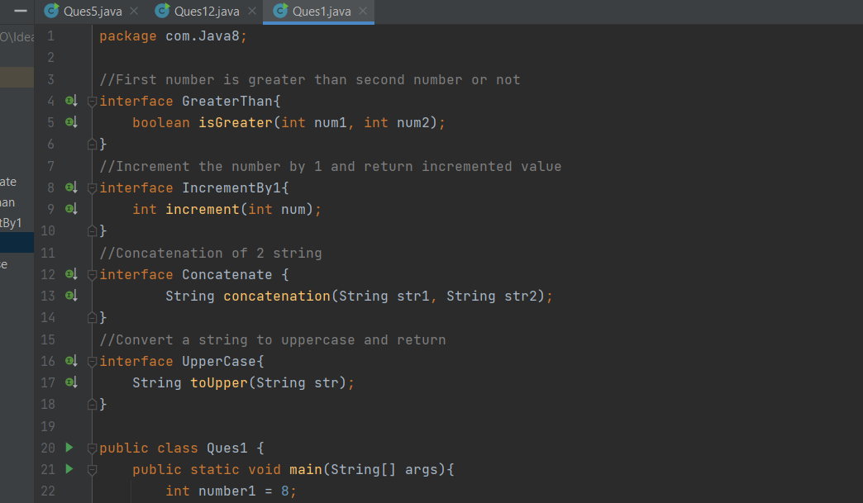
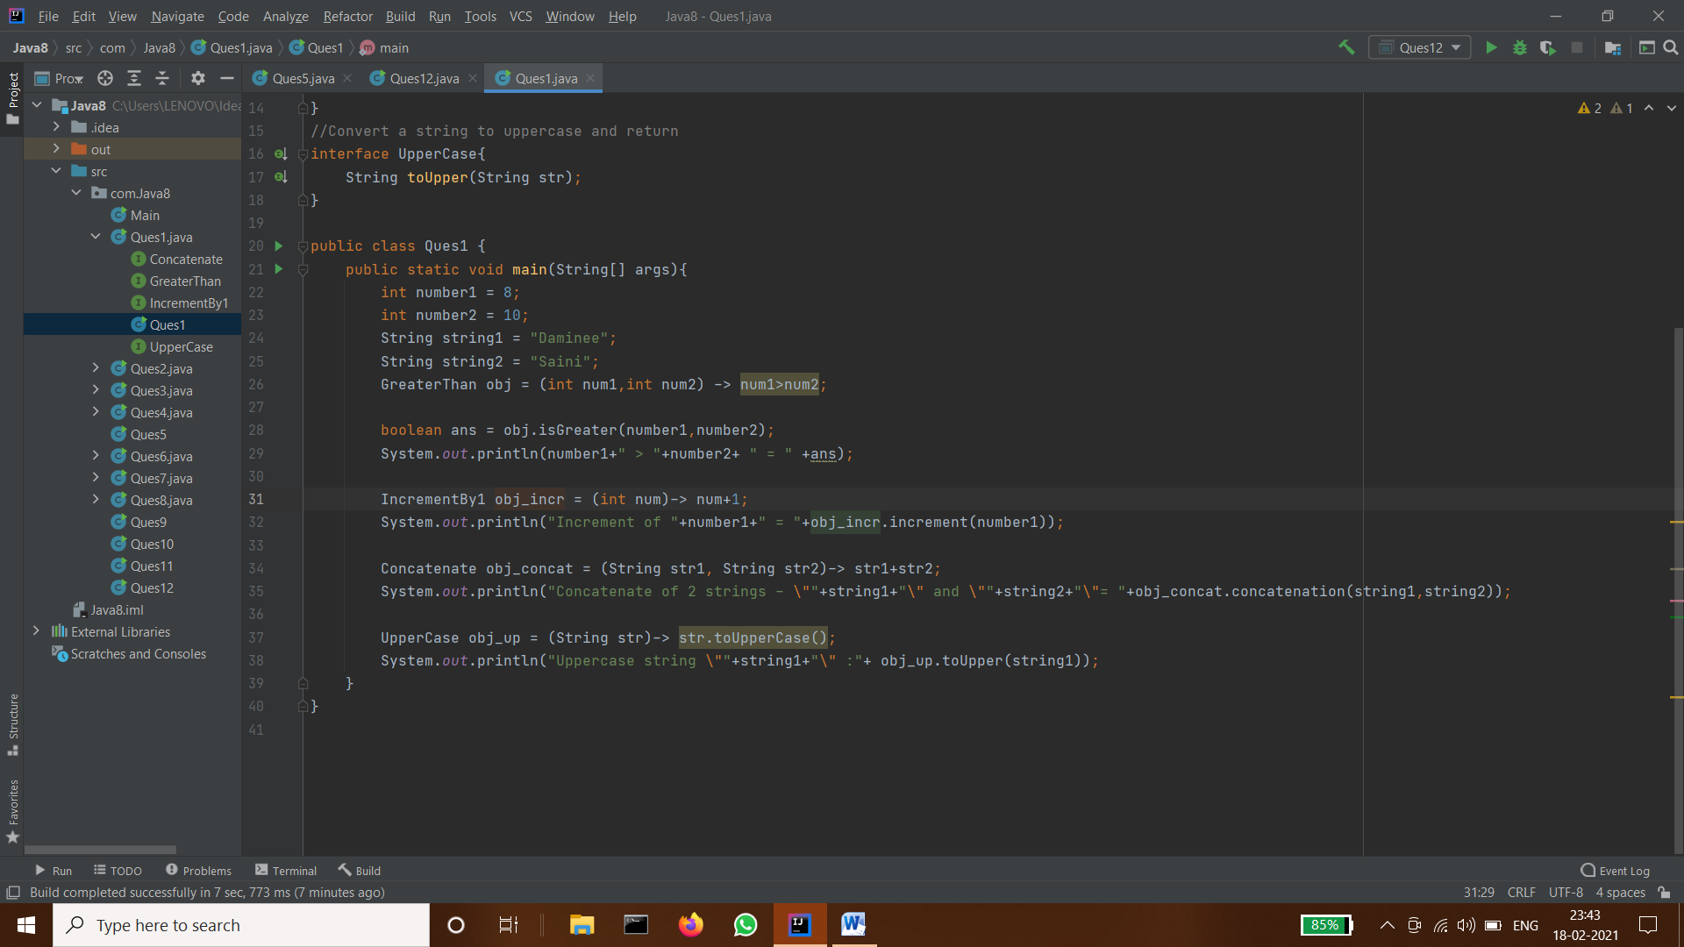
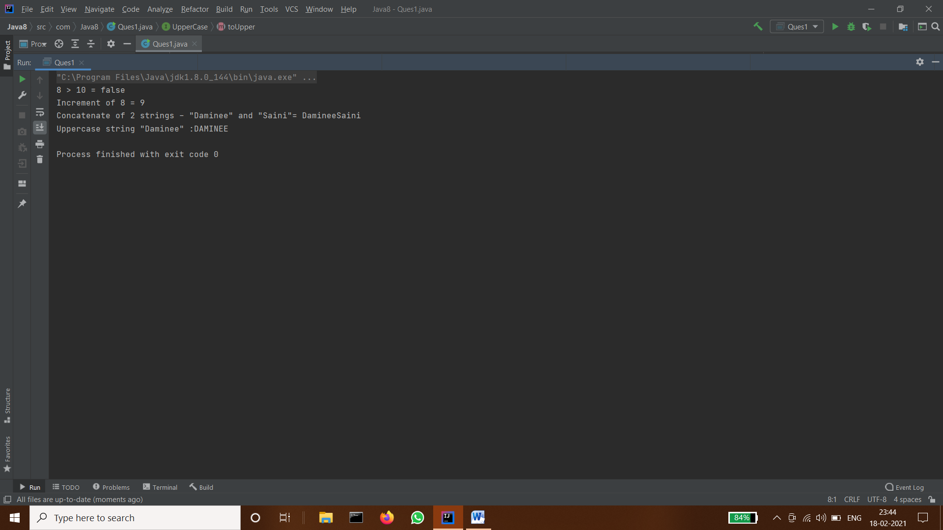

- Create a functional interface whose method takes 2 integers and return one integer.
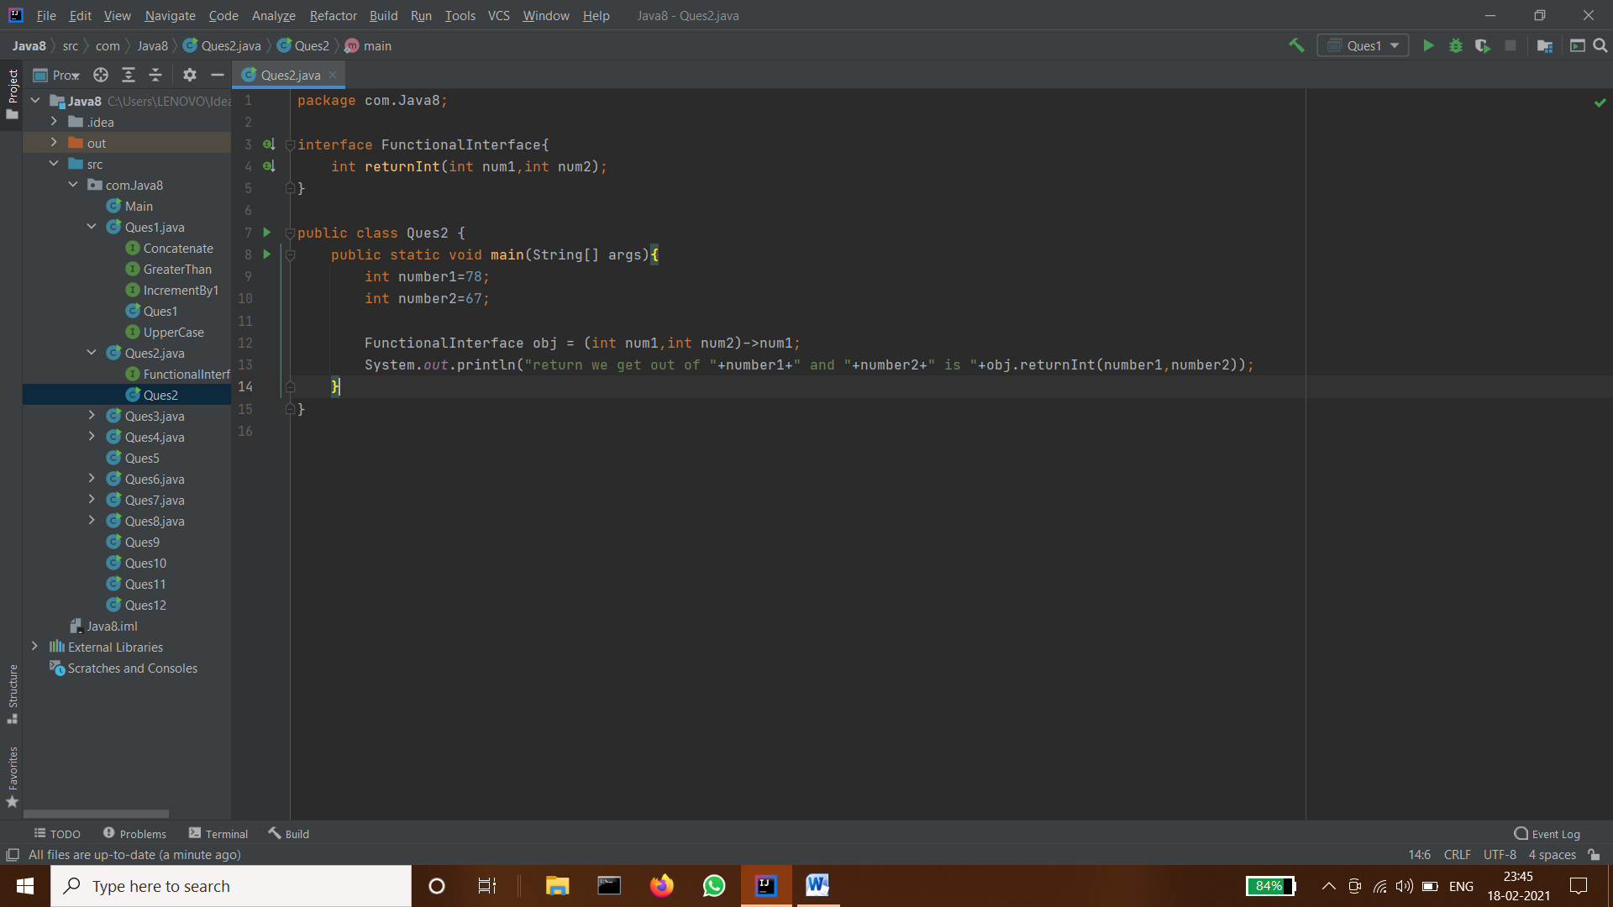
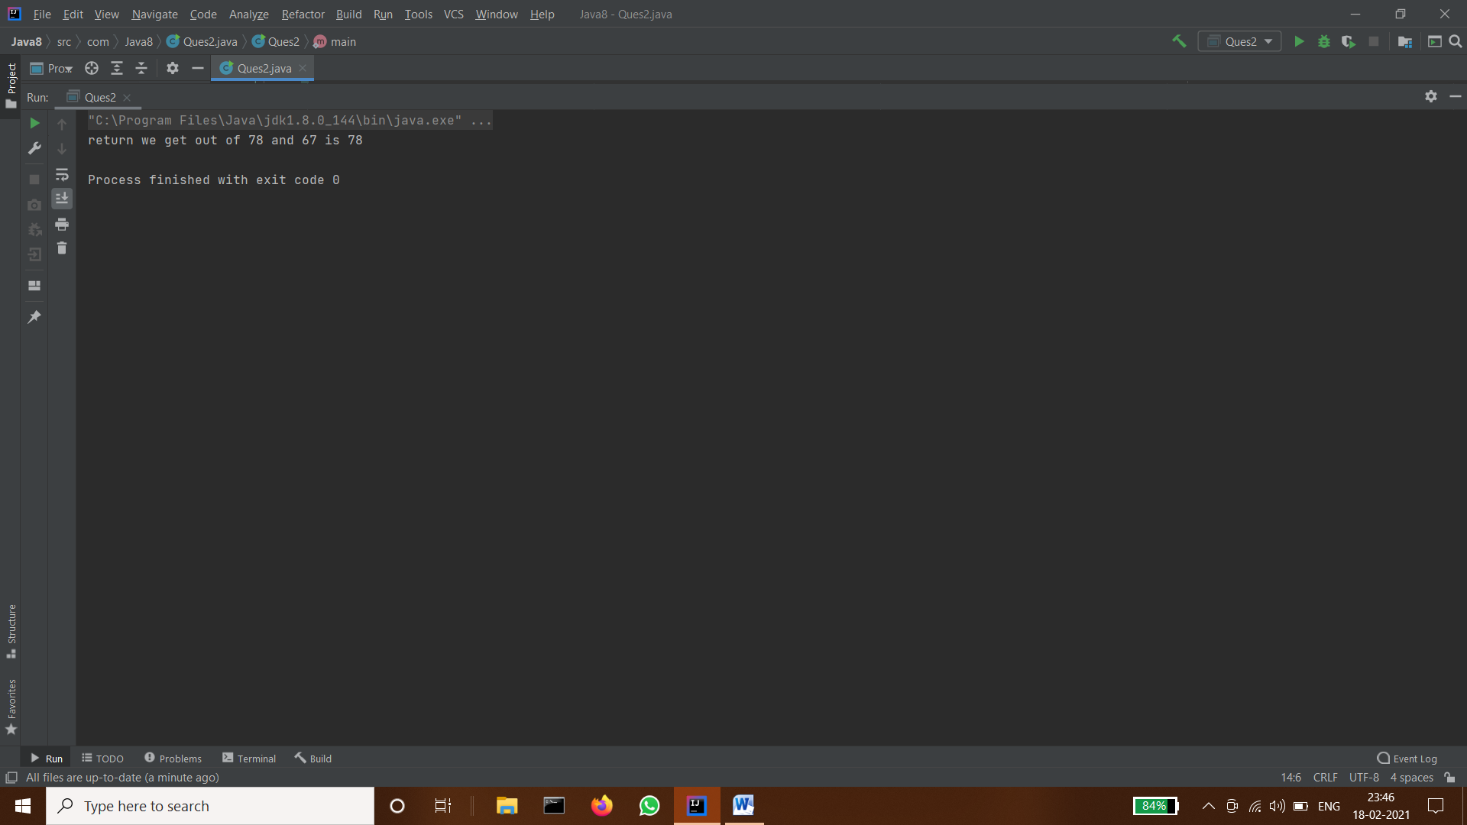

- Using (instance) Method reference create and apply add and subtract method and using (Static) Method reference create and apply multiplication method for the functional interface created.
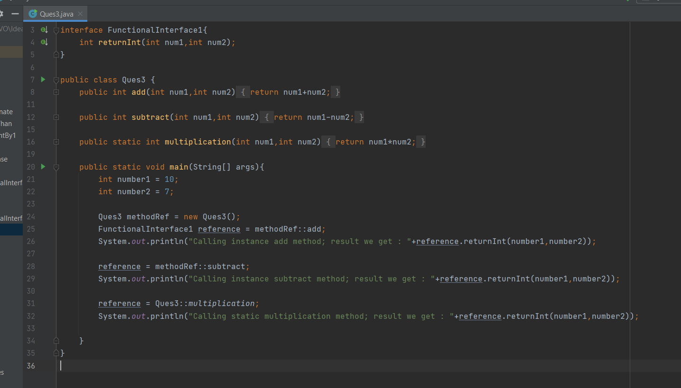
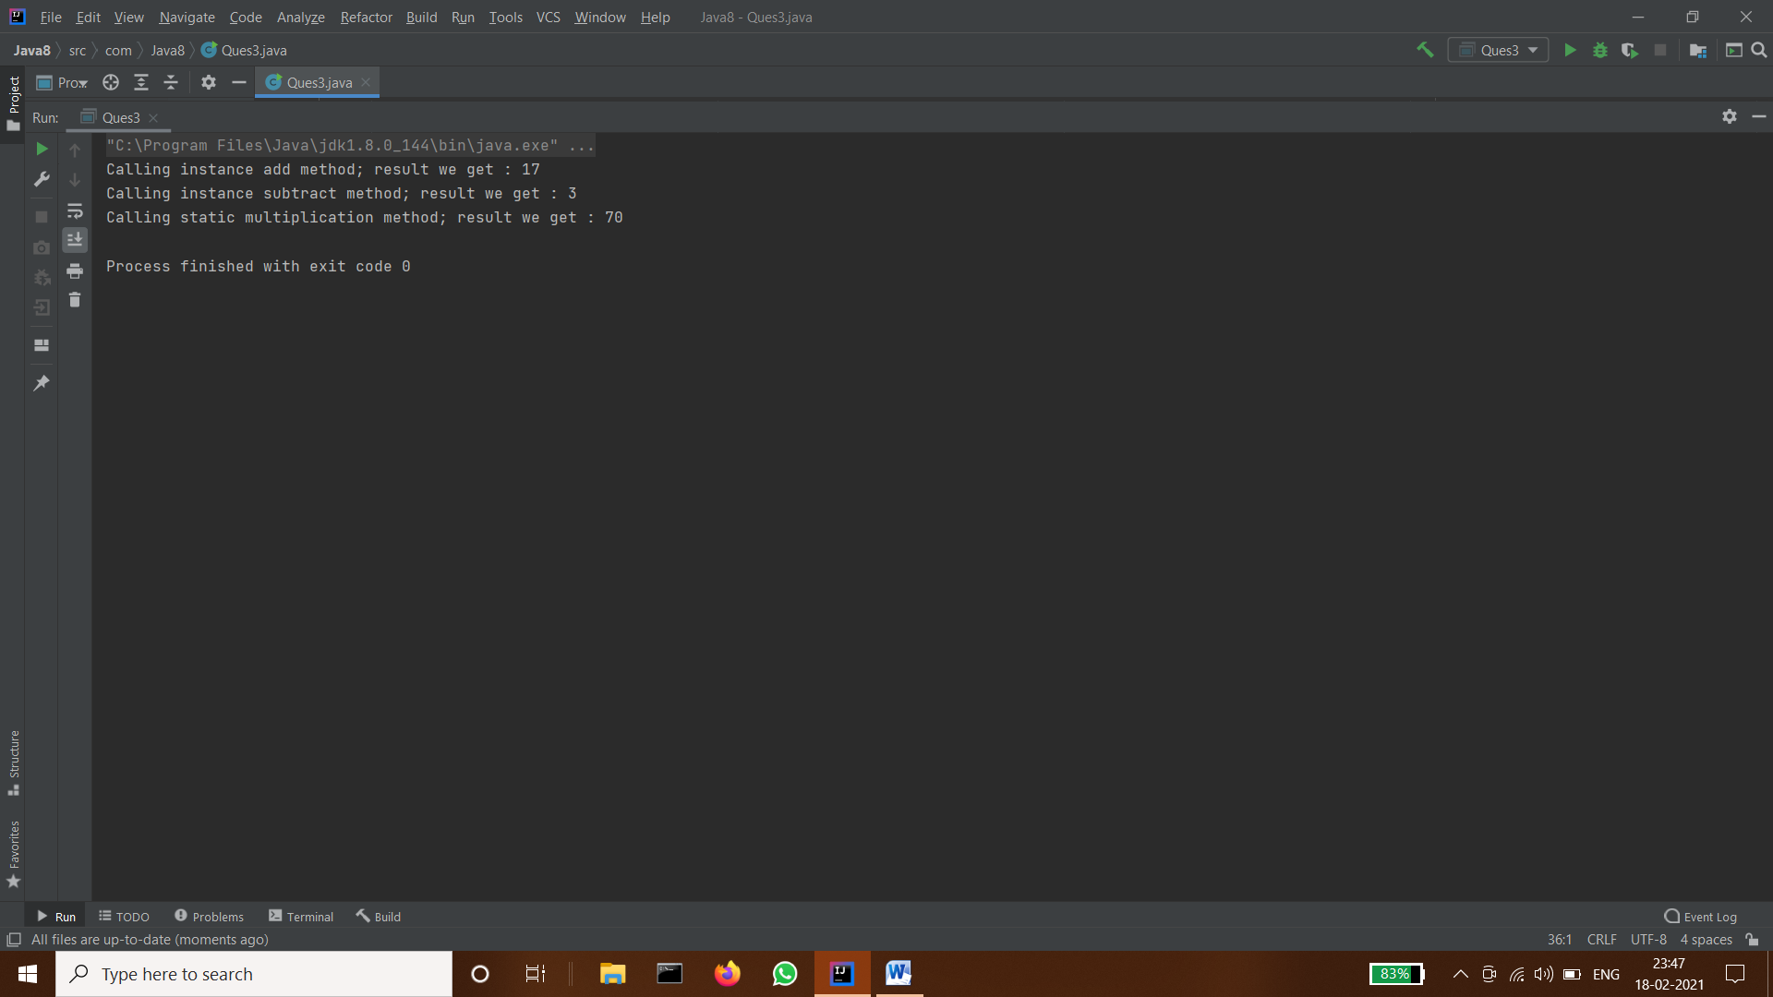

- Create an Employee Class with instance variables (String) name, (Integer)age, (String)city and get the instance of the Class using constructor reference
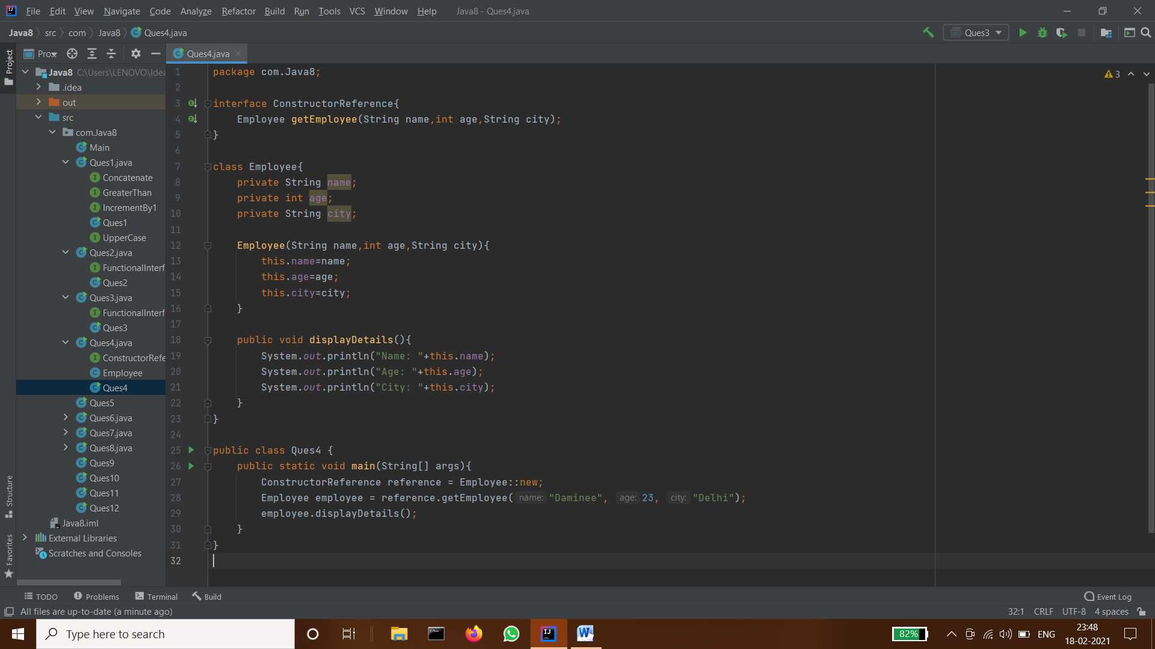
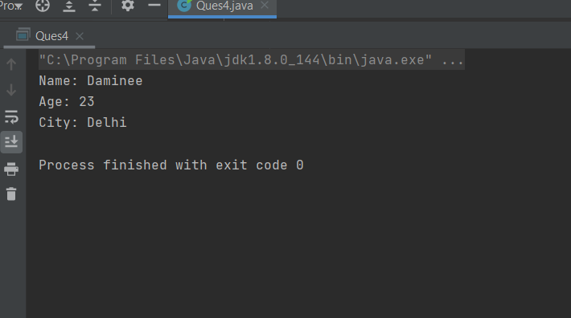

- Implement following functional interfaces from java.util.function using lambdas:
(1) Consumer
(2) Supplier
(3) Predicate
(4) Function
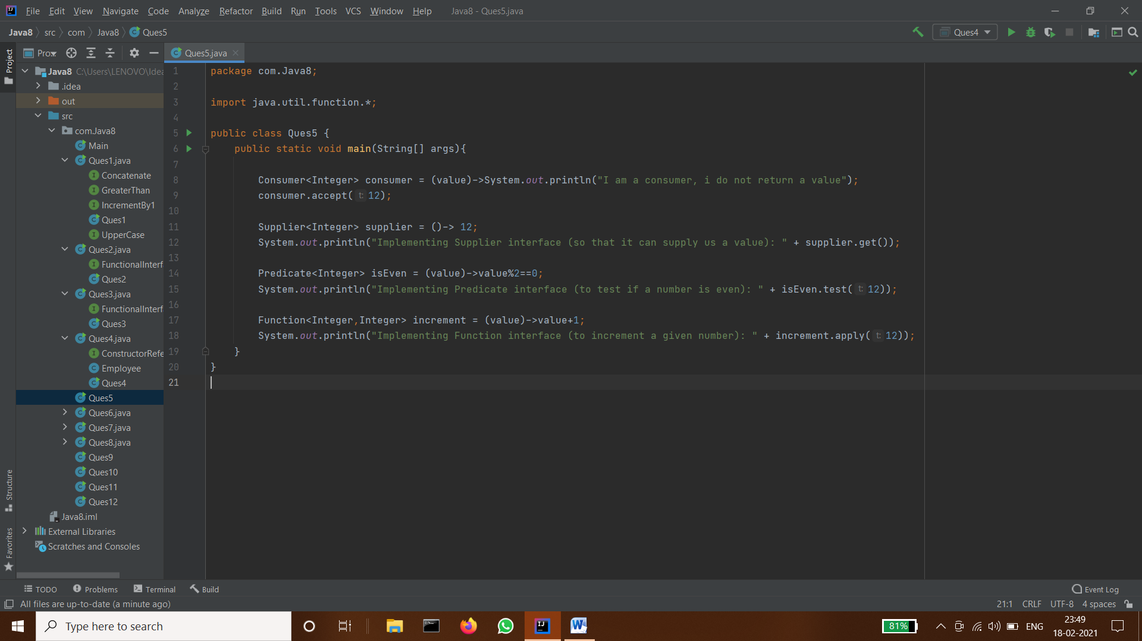
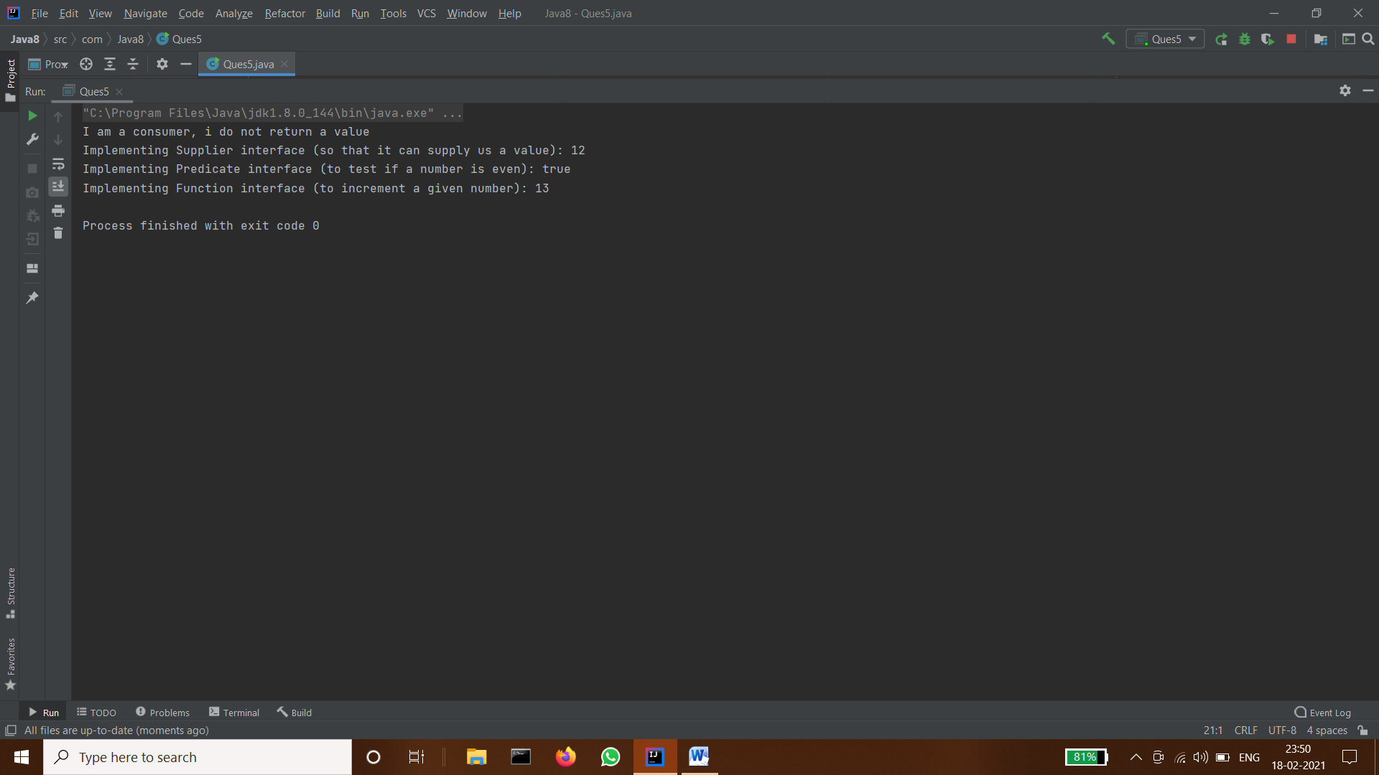

- Create and access default and static method of an interface.
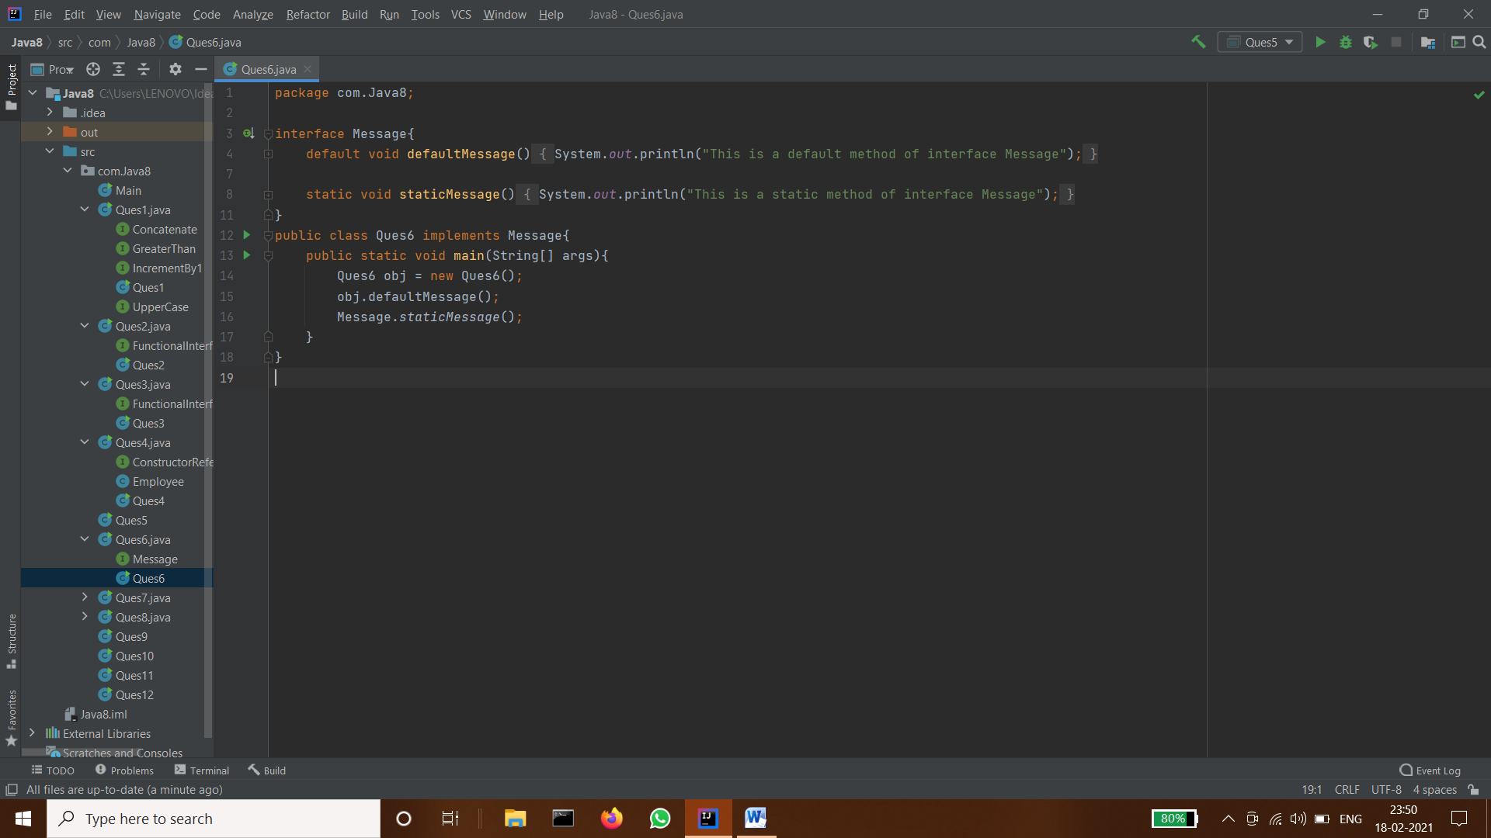
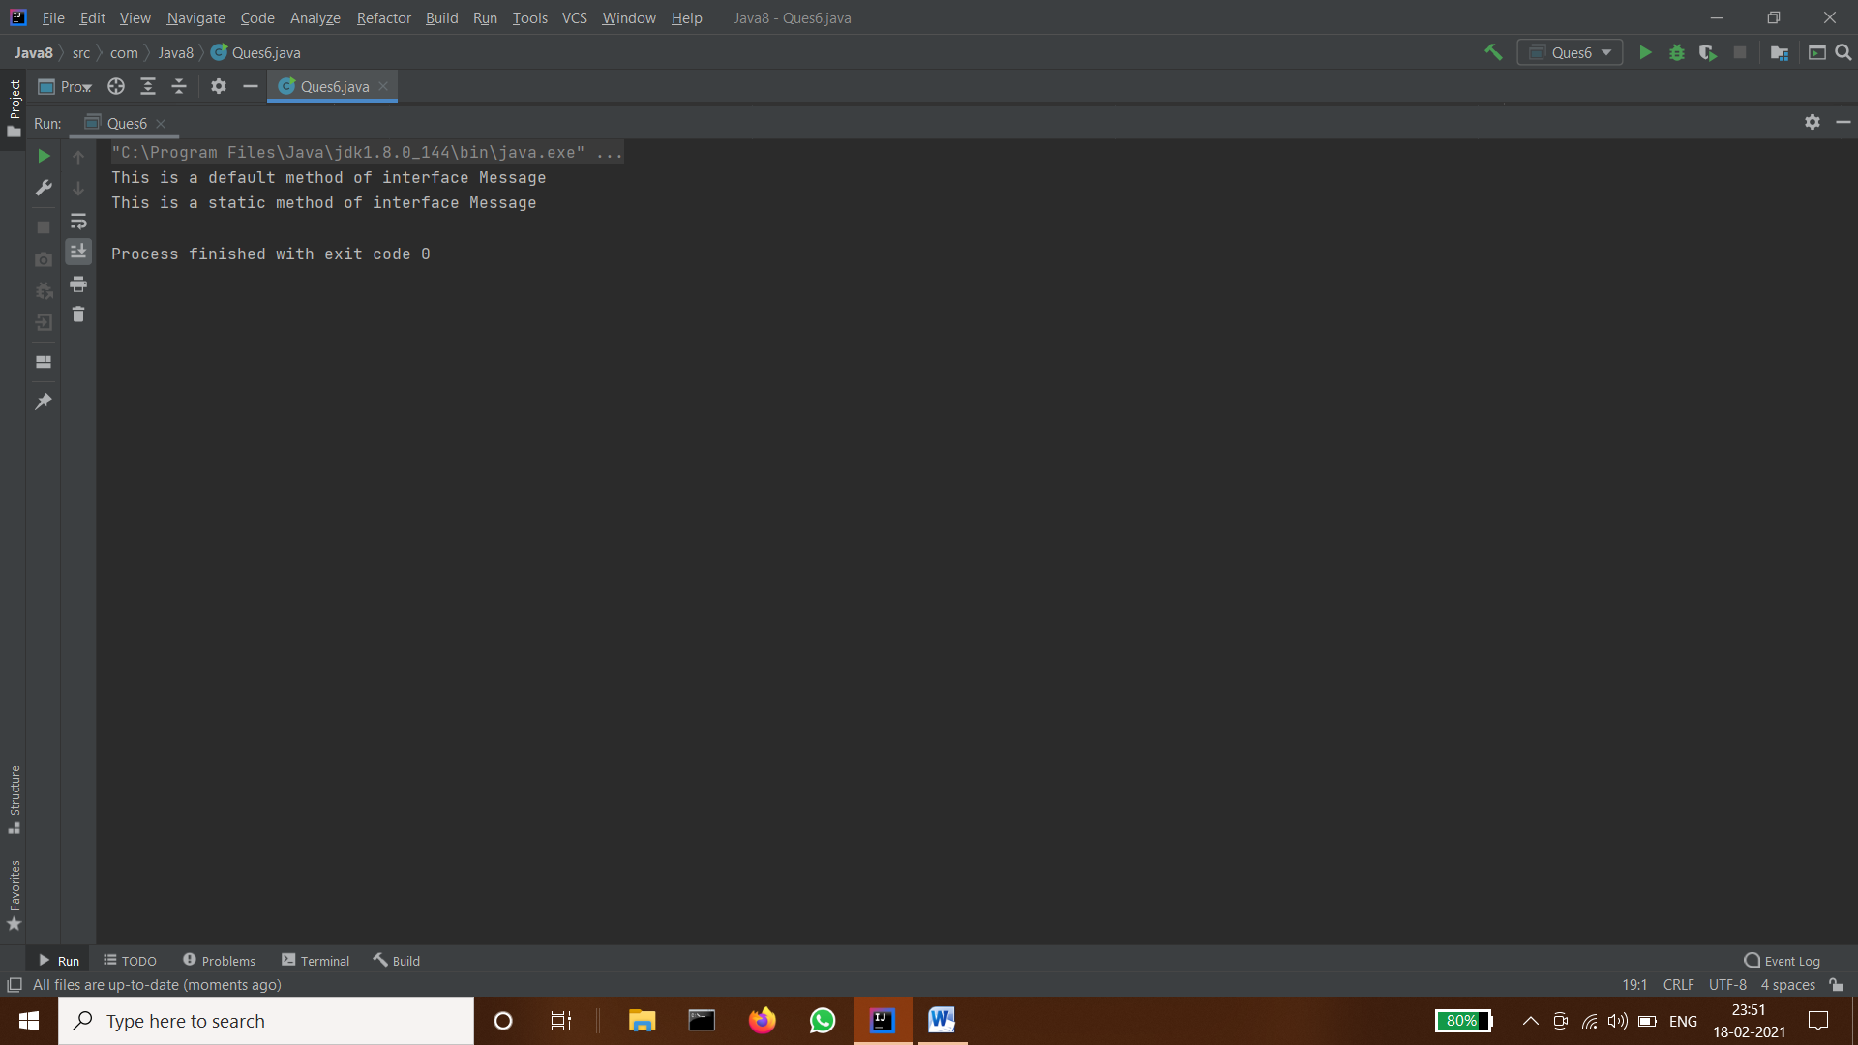

- Override the default method of the interface.
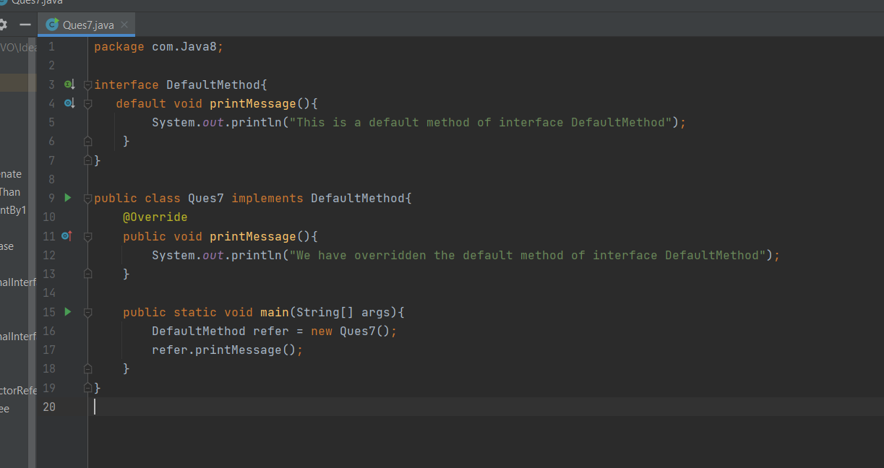
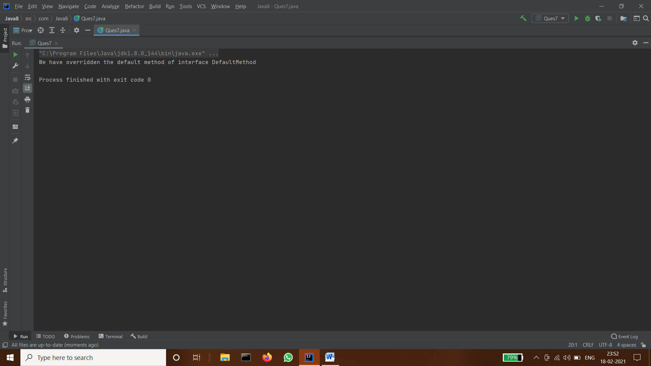

- Implement multiple inheritance with default method inside interface.
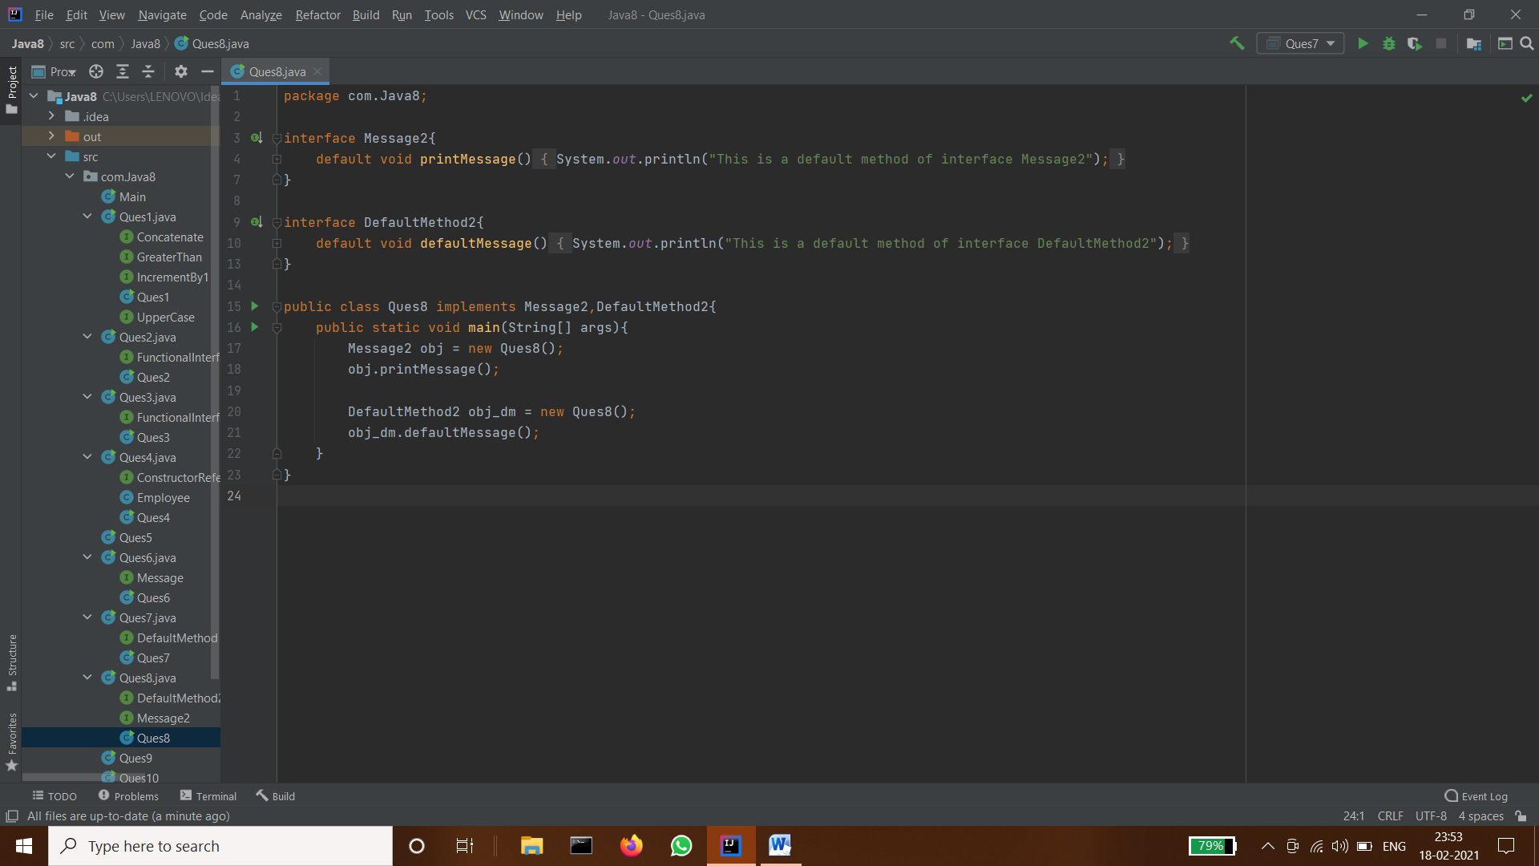

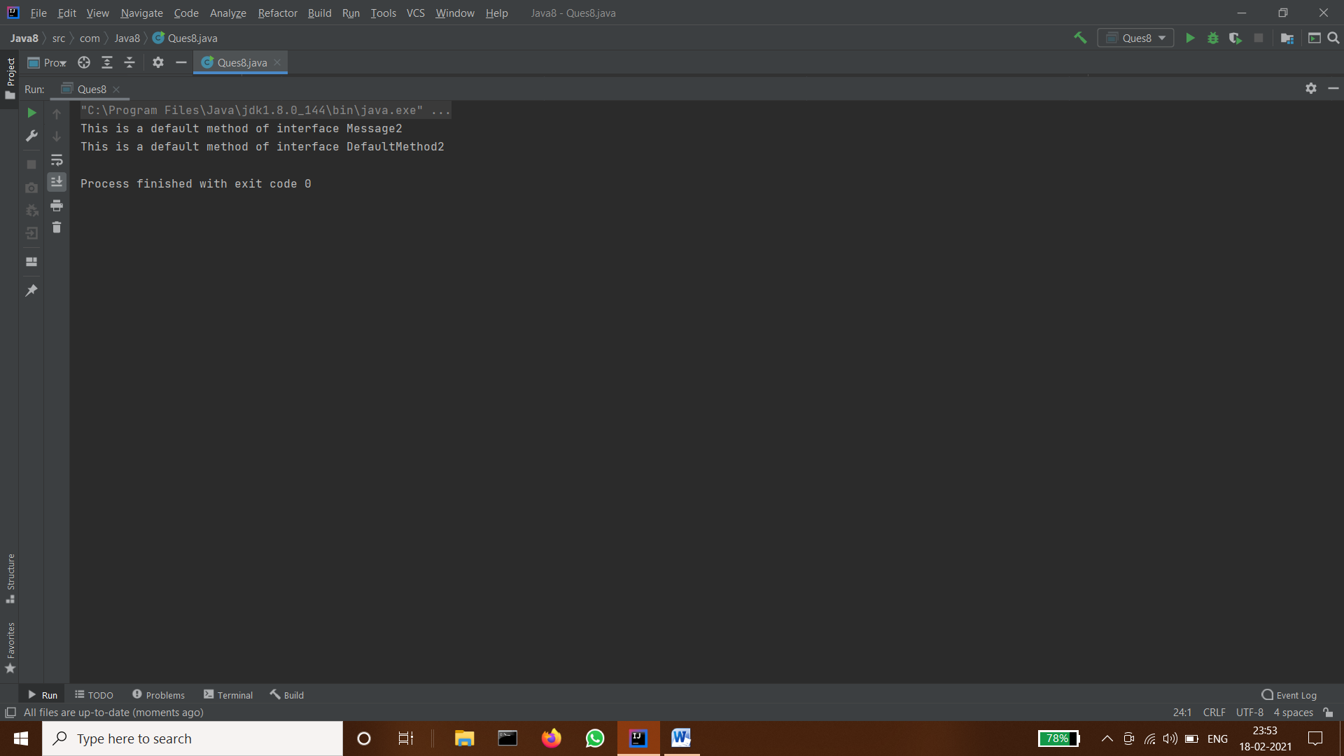

- Collect all the even numbers from an integer list.
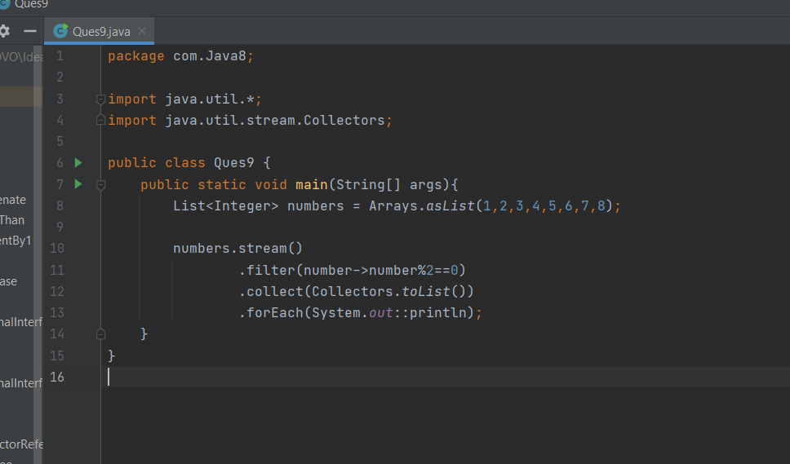
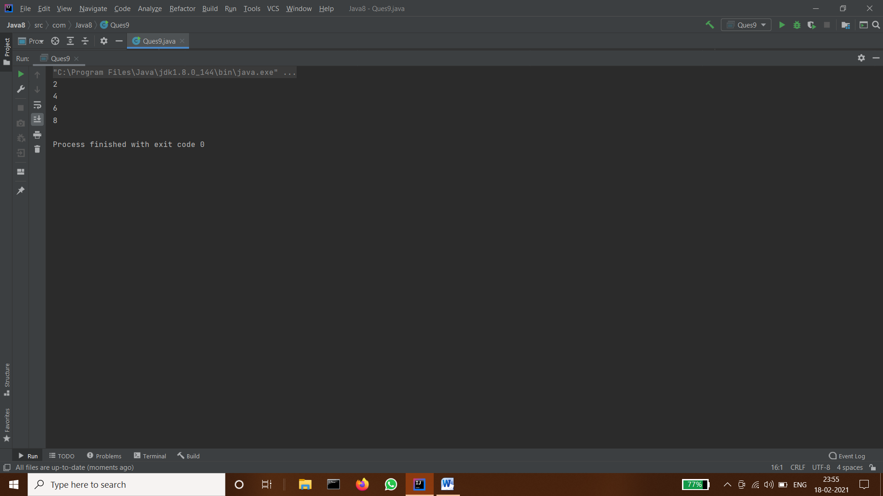

- Sum all the numbers greater than 5 in the integer list.
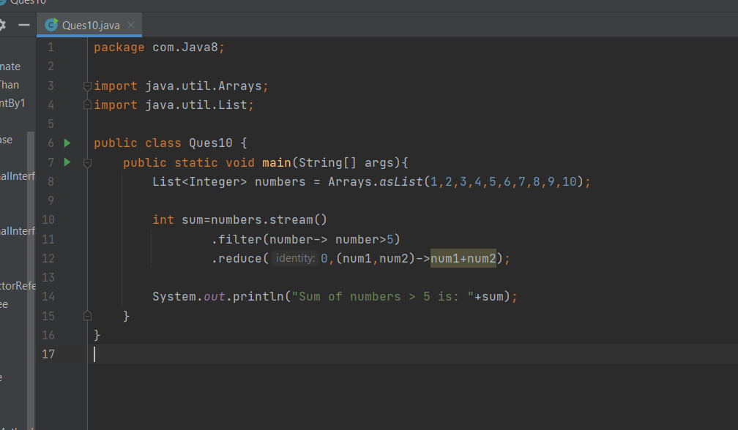
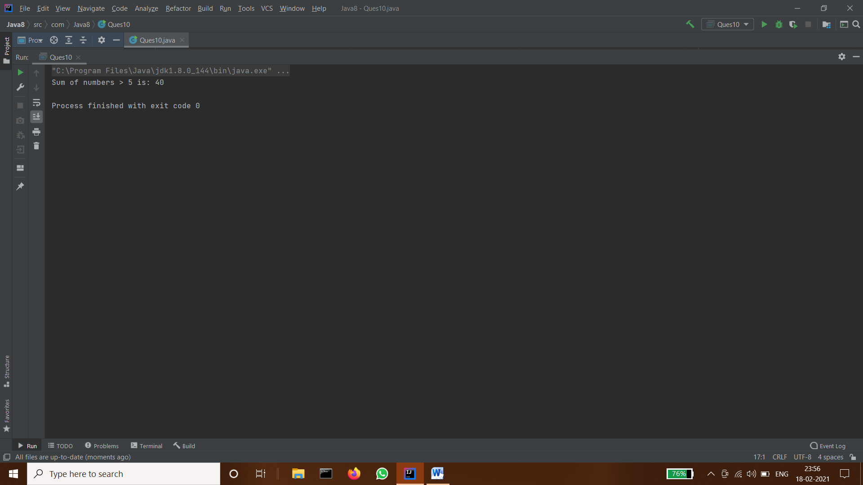

- Find average of the number inside integer list after doubling it.
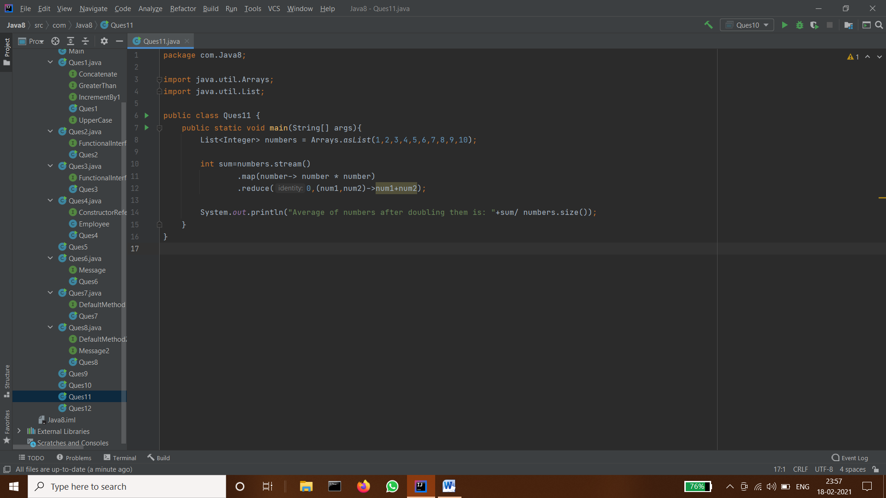
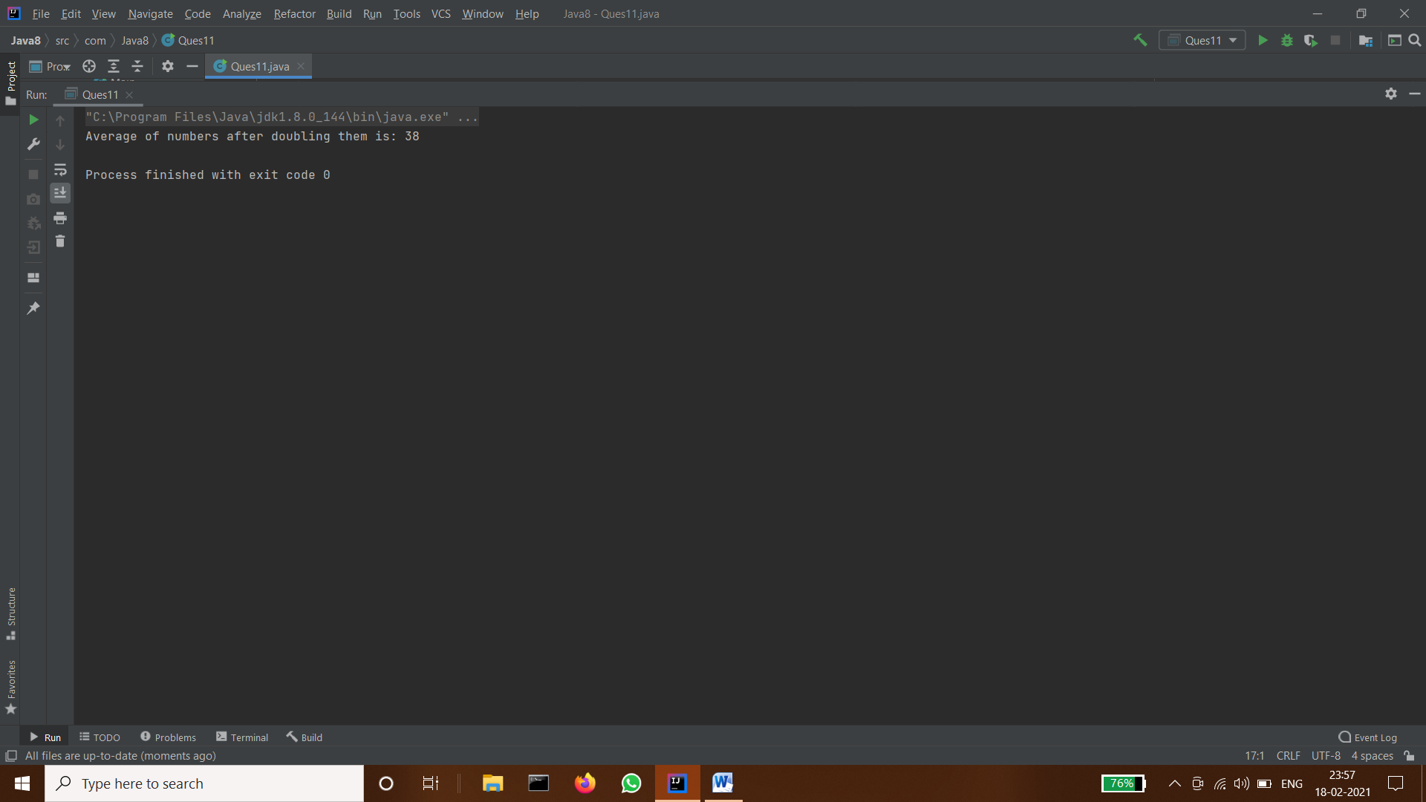

- Find the first even number in the integer list which is greater than 3.


